Semantic Data Search Service
This section provides some additional technical details about the semantic data search service, which supports search for relevant data within the data space, based on its ontology and the analytical use cases. It is a Web service, accessible using standard Web browser at https://datasearch-diversea.gate-ai.eu. The service supports two different user profiles: free search for public data, or search and download of project data for registered users. The profile roles are allocated during the registration by the service administrator (email: nikolay.shivarov@gate-ai.eu). Fig. 6 show the search for data from the Black Sea for analysis of the plankton distribution and Tab. 5 summarizes the command protocol.
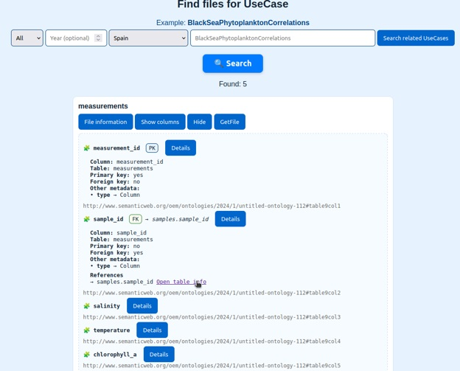
Figure 6. Search for Black Sea plankton distribution (https://datasearch-diversea.gate-ai.eu)
Core of the service is the graph database GraphDB, which hosts the ontology of the project on the GATE Institute network. The service searches for data both in the structured data repository and in the raw datasets file repository of DiverSea Data Space.
Operation | Parameters | Description | Tools
Query  specification | Grouping, Splitting, Relating, Classifying | Interactive formation of the search query using drop-down menu options and search strings using only a standard Web browser | JavaScript
Query  generation | Language,  Destination | Automatic parsing and translation into the semantic query language SPARQL | Python
Query  execution | as in the original formulation | Search for raw data files, database tables and columns matching the query in SPARQL | GraphDB, PostgreSQL
Information presentation | as retrieved | List or table of findings, described using location, name, type, place, time, etc. | JavaScript
Table 5. Semantic Search Operations

